Chapter 7 Elements
extra worksheet 1: Properties of water
Science understanding Verbal/Linguistic, Visual/Spatial
Name: Class: Date:
Water is one of the most common compounds on Earth. It covers 71% of the Earth’s surface and makes up over 50% of your body. It is easy to forget that water has some very special properties that are unlike any other compound. Without these special properties, life as we know it could not exist.

Melting and boiling points of water
Water is one of the only compounds that you can see as a solid, liquid or gas at temperatures commonly found on Earth. In your kitchen you can find water as a solid (ice cubes), liquid (water from the tap) and gas (steam from a kettle or humidity in the air).
In fact, the melting and boiling points of water were used to define the Celsius temperature scale. The melting point of water at sea level was used to define 0°C in the Celsius scale. The boiling point of water at sea level was used to define 100°C.

Density of water
Another unusual property of water is that its solid form (ice) is less dense than its liquid form (liquid water). As a result, ice floats in water. This is something you can see with ice cubes in a drink or icebergs on the ocean. However, this property is actually quite unusual. Most substances are more dense in the solid form and so sink to the bottom of the liquid.
Water is most dense at 4°C (four degrees above its freezing point). This unusual property of water is of critical importance to aquatic (water dwelling) plant and animal life in cold climates. It means that water at 4°C sinks to the bottom of a lake and water at 0°C floats to the top. As a result, lakes freeze from the top down. This allows plants and animals in the lake to continue living, foraging and breeding in the lakebed.

The universal solvent
Water is also very good at dissolving a large range of substances. For this reason, water is sometimes referred to as ‘the universal solvent’. This term is slightly misleading because water cannot dissolve all substances (for example, oil, gold, chalk). Still, water is a very important solvent and is used to make solutions of most of the compounds you use in the laboratory.

Questions
1 List other substances that you find in your everyday life that can be commonly found in two or more states and fill in the table below. Can you think of any compounds that can be commonly found in all three states?
 | Solid | Liquid | Gas
water | ✓ | ✓ | ✓

2 Use the data in the table below to construct a graph of the density of water as a function of temperature. Axes are provided for you below.
 | Temperature  (°C) | Density (kg/m³)
Liquid water | 30 | 995.6
Liquid water | 25 | 997.0
Liquid water | 22 | 997.8
Liquid water | 20 | 998.2
Liquid water | 15 | 999.1
Liquid water | 10 | 999.7
Liquid water | 4 | 1000.0
Liquid water | 0 | 999.8
Solid water | 0 | 916.7
Solid water | -5 | 917.1
Solid water | -10 | 917.5
Solid water | -15 | 917.9

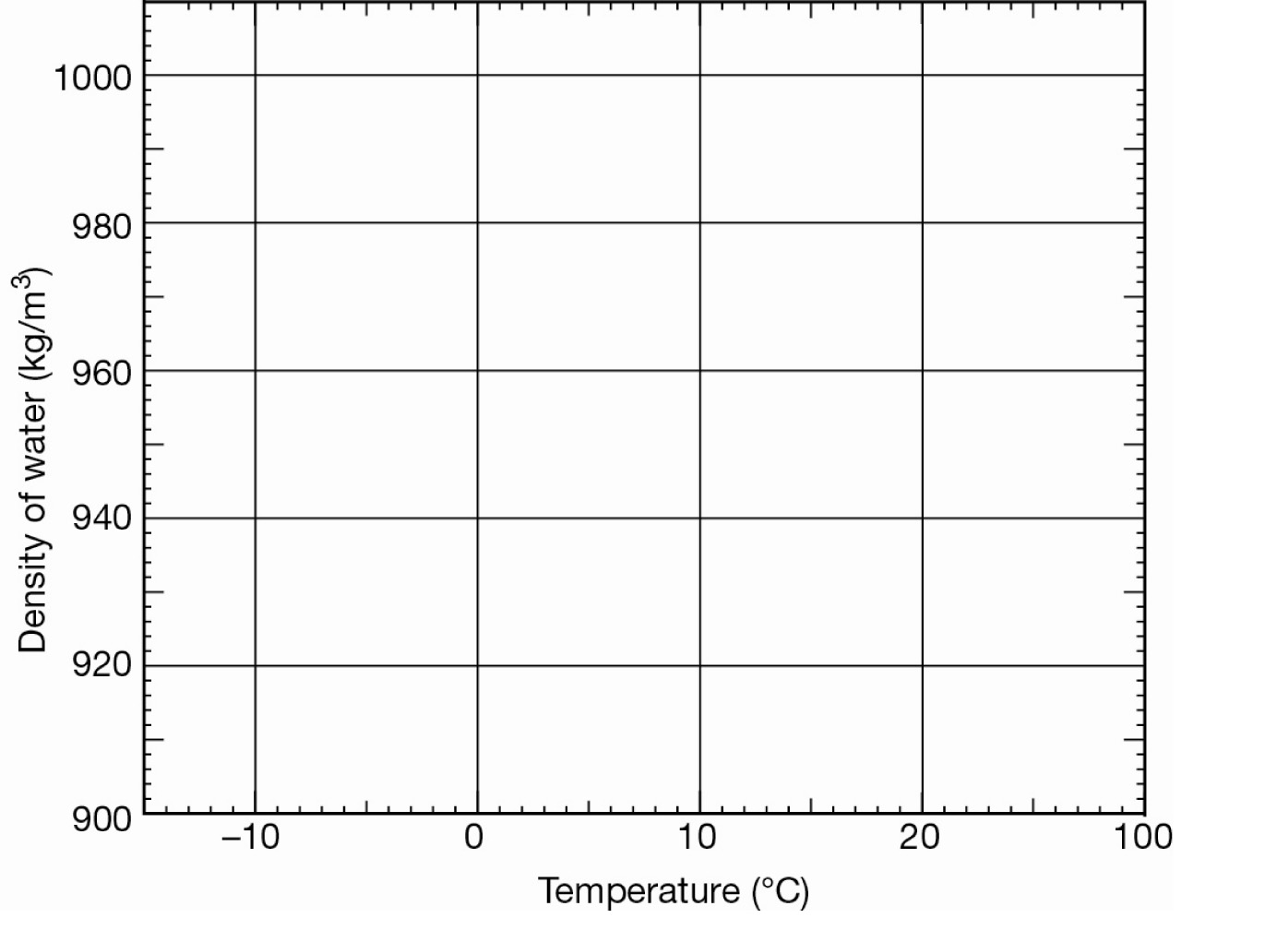
3 Identify by labelling the graph at what temperatures the water is solid and at what temperatures the water is liquid.
4 Describe the shape of the graph from lowest temperature to highest temperature.

5 Solubility is a measure of how well a substance dissolves in a solvent. Create graphs of the solubility of sugar and oxygen in water against temperature from the data in the table below.
Temperature (°C) | 0 | 10 | 20 | 30 | 40 | 50
Solubility of sugar (g/L) | 1792 | 1905 | 2039 | 2195 | 2381 | 2604
Solubility of oxygen (g/L) | 0.0146 | 0.0113 | 0.0091 | 0.0076 | 0.0065 | 0.0056

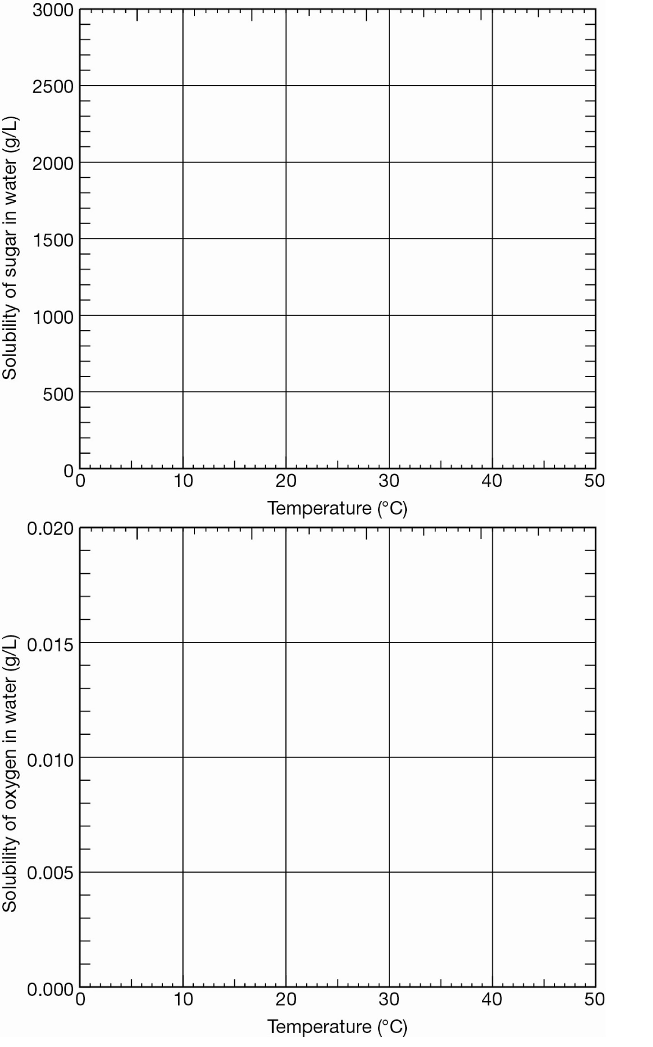
6 Explain why it is better to plot the data on separate graphs even though the units of measurement are the same on both axes.

7 Describe the differences between the solubility of sugar and oxygen in water.

8 Propose what you should do to get the most concentrated solution of sugar in water.

9 Propose what you should do to get the most concentrated solution of oxygen in water.

